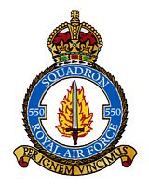
`

550 SQUADRON ASSOCIATION REUNION
Friday 11th and Saturday 12th July 2025

BOOKING FORM
Name of Member:
Accompanied By:
Home Address:

Telephone No Email:
Special Requirements (eg wheelchair etc) :
Accommodation at the Ashbourne Hotel
Members and friends must reserve rooms directly with the hotel and pay their own accounts on departure. The Association will not be booking any individual rooms, but we would like to know the names of those who are staying.

Friday 11th July:

Saturday 12th July:

Church and Afternoon Tea & Cakes. Number of places:

Associated Events – Sunday 13th July
Tour of North Killingholme Airfield by car - led by George Turner Number of places:
This is an informal tour that George is happy to lead if there is sufficient interest

Annual Subscription
Annual Subscription for year beginning 1st July 2025 will remain at £5.50 per person. Payments by bank transfer are preferred and the association’s bank details are as follows:

Sort Code : 30 - 93 - 72 Account Number : 01206018 Please reference any payments with your name.

If you have not already made bank arrangements, you are invited to pay now by cheque

Number of members ___________ @£5.50 per head: £
Names of members being paid for

TOTAL PAYMENT : £

Cheques should be made out to “550 Squadron Association” and returned with this completed booking form NO LATER THAN FRIDAY 20th JUNE to:

Liz Broddley, 15 St Crispins Close, North Killingholme, North Lincs, DN40 3JN
Telephone: 01469 540628 Email: lbroddley@gmail.com

Meal Requirements
The menus for Friday and Saturday nights are shown below. Please indicate below your choices. Members must pay the hotel directly for all meals taken.
Please advise below if you have any special dietary requirements:

Friday 11th July 7.30pm. Relaxed, informal evening . No seating plan.

2 courses £24 per person (Starter & Main - or - Main & Dessert)
3 courses £29 per person ( Starter, Main & Dessert)

STARTERS:
 | Name | Name | Name | Name
Leek & Potato Soup
Deep Fried Brie
Beef Fritter
Chicken Liver Parfait
MAIN COURSES:
Battered or Grilled Haddock
Gammon Steak
Beef & Ale Pie
Tomato, Basil & Halloumi Risotto
DESSERTS:
Treacle Sponge
Duo of Chocolate
Lemon Meringue Roulade

Saturday 13th July 7.30pm. Formal Dinner with seating plan.
3 courses £34.00 per person ( Starter, Main & Dessert)

Seating Preference: Please let me know if you would like to sit with anyone in particular:

STARTERS:
 | Name | Name | Name | Name
Vegetable Soup
Cheese & Onion Quiche
Chicken & Mushroom Terrine

MAIN COURSES:
Roast Rib of Beef
Roast Haddock
Roast Loin of Pork
Tomato, Basil & Halloumi Risotto

Apple Pie
Ice Cream Terrine
White Chocolate Cheesecake

Saturday 12th July 2025

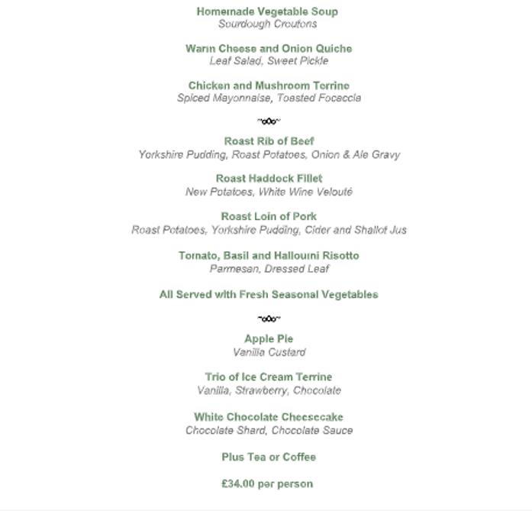

Friday 11th July 2025
